**For While Do while Break Continue Assignment**

1**. WAP to read a number n and to display the cumulative sum of factorial of all numbers upto n . (use for or while)**

**Input: 4**

**Ouput: 4!+3!+2!+1! = 32**

Ans:

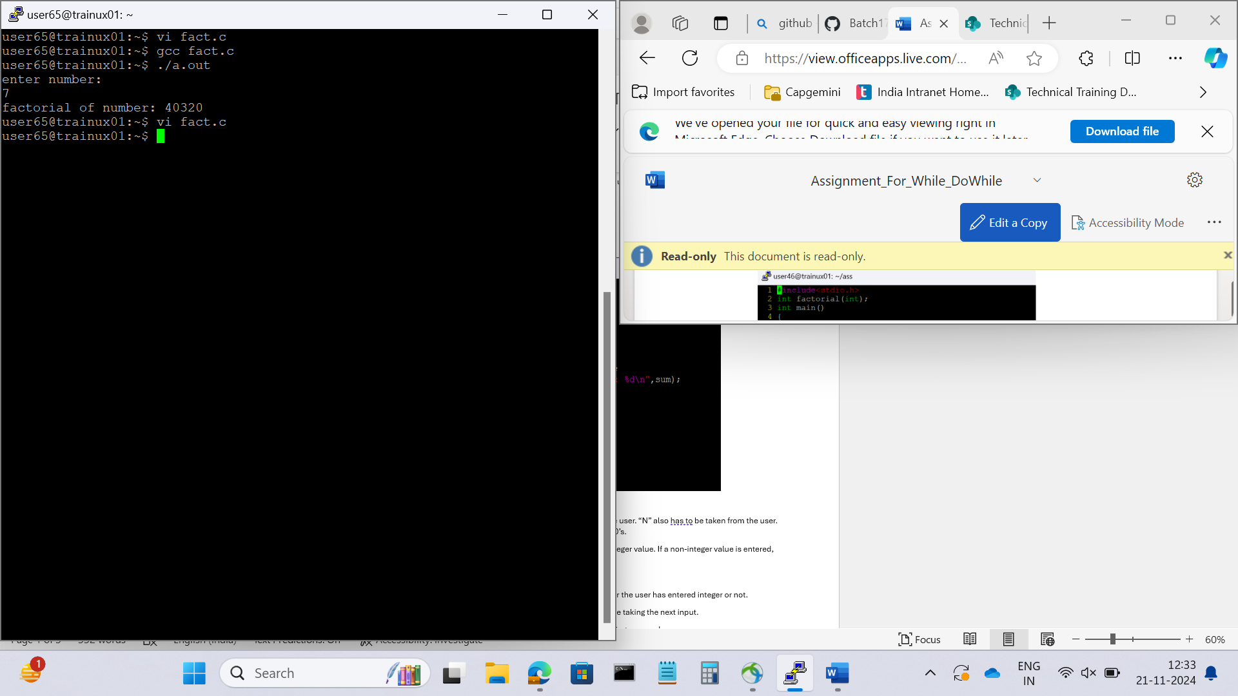

**2. Write a program to accept “N” integers from the user. “N” also has to be taken from the user. Take the count of +ve numbers, -ve numbers and 0’s.**

**However the program should not accept a non-integer value. If a non-integer value is entered, used must be asked to re-enter.**

**[Hint:**

**a. Use the return value of scanf to find out whether the user has entered integer or not.**

**b. You also will have to clear the input buffer before taking the next input.**

**For clearing the input buffer, use one of the following approaches**

**Ø while (getchar() != '\n'); // keep reading till newline and discard the characters**

**Ø scanf(“%*s”); // read and discard one string**

**3. Write a program to continuously read a string of maximum length 80 chars, End the program if string is END, else convert to upper case, display and continue. (use while)**

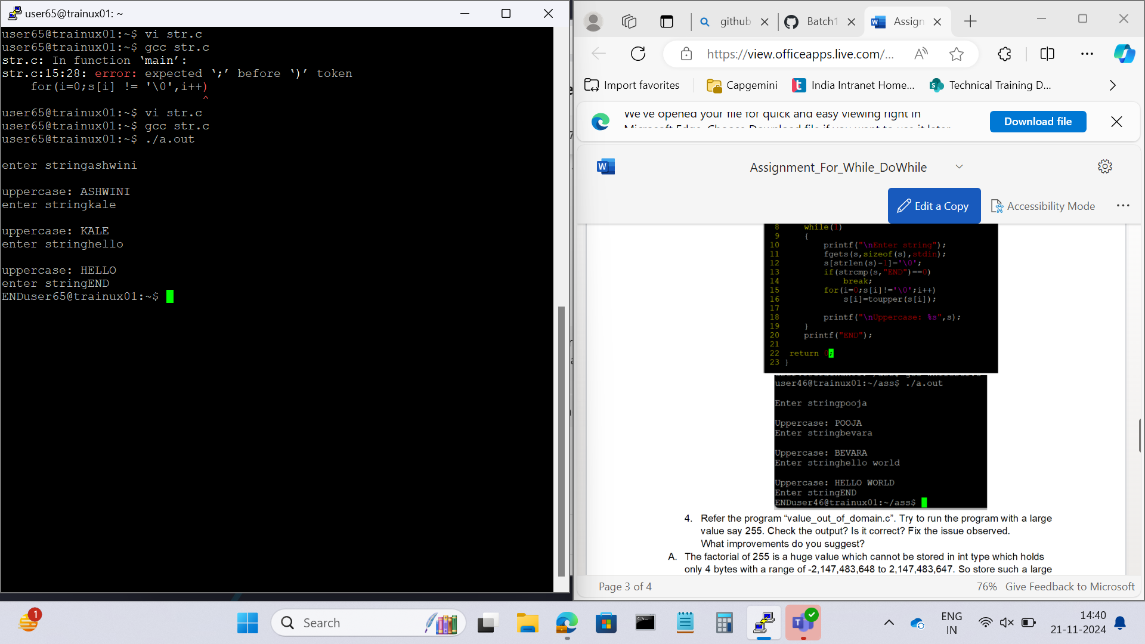

**4. Refer the program “value_out_of_domain.c”. Try to run the program with a large value say 255. Check the output? Is it correct? Fix the issue observed.What improvements do you suggest?**

**Ans:** The factorial of 255 is a huge value which cannot be stored in int type which holds only 4 bytes with a range of -2,147,483,648 to 2,147,483,647. So store such a large values we need to define an array with large size like array[1000] that holds the value.

**5. Refer the code below. It does not output anything. Fix it.**

**#include <stdio.h>**

**int main()**

**{**

**int x = 5;**

**while (x > 0);**

**{**

**printf( "Value of x :%d \n", x);**

**x--;**

**}**

**return 0;**

**}**

**Ans**:There is a semicolon at the end of while loop. Here the while condition will gets executed continuously and do not enter the block. Therefore the code doesnot give any output.

**6. Analyse the code, identify the issues**

**#include <stdio.h>**

**int main()**

**{**

**float cnt = 0, num = 1000;**

**do**

**{**

**printf ("\n%d\n%d", num,cnt);**

**num /= cnt;**

**} while (cnt --); /* End of while */**

**return 0;**

**}**

**Ans**:The variables cnt and num are declared as floats but they are given format specifiers as %d. It can be rectified by taking %f as format specifiers.